Category Overview
6.33.43AM
May 13, 2021
Unnamed Project
Time Units:
Replications:
500
Hours
Values Across All Replications
Key Performance Indicators
Average
System
Number Out
3
Model Filename:
Page
of
1
5
D:\A_Sem_1\Simulation\Final Project\Simulation_Final_Project_Inventory_Management_Scenario2

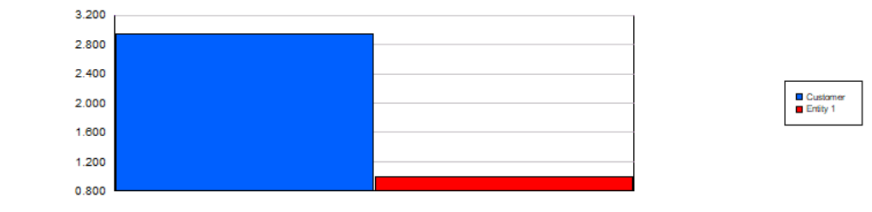
Category Overview
6.33.43AM
May 13, 2021
Unnamed Project
Time Units:
Replications:
500
Hours
Values Across All Replications
Entity
Time
VA Time
Maximum
Average
Minimum
Average
Half Width
Average
Minimum
Value
Maximum
Value
0.00
Customer
< 0.00
0.00
0.00
0.00
0.00
NVA Time
Maximum
Average
Minimum
Average
Half Width
Average
Minimum
Value
Maximum
Value
0.00
Customer
< 0.00
0.00
0.00
0.00
0.00
Wait Time
Maximum
Average
Minimum
Average
Half Width
Average
Minimum
Value
Maximum
Value
0.00
Customer
< 0.00
0.00
0.00
0.00
0.00
Transfer Time
Maximum
Average
Minimum
Average
Half Width
Average
Minimum
Value
Maximum
Value
0.00
Customer
< 0.00
0.00
0.00
0.00
0.00
Other Time
Maximum
Average
Minimum
Average
Half Width
Average
Minimum
Value
Maximum
Value
0.00
Customer
< 0.00
0.00
0.00
0.00
0.00
Total Time
Maximum
Average
Minimum
Average
Half Width
Average
Minimum
Value
Maximum
Value
0.00
Customer
< 0.00
0.00
0.00
0.00
0.00
Other
Number In
Maximum
Average
Minimum
Average
Half Width
Average
Customer
0.04
2.9500
4.0000
2.0000
Entity 1
0.00
1.0000
1.0000
1.0000
Model Filename:
Page
of
2
5
D:\A_Sem_1\Simulation\Final Project\Simulation_Final_Project_Inventory_Management_Scenario2

Category Overview
6.33.43AM
May 13, 2021
Unnamed Project
Time Units:
Replications:
500
Hours
Values Across All Replications
Entity
Other
Number Out
Maximum
Average
Minimum
Average
Half Width
Average
Customer
0.04
2.9500
4.0000
2.0000
Entity 1
0.00
0.00
0.00
0.00
WIP
Maximum
Average
Minimum
Average
Half Width
Average
Minimum
Value
Maximum
Value
0.00
Customer
< 0.00
0.00
0.00
0.00
1.0000
1.0000
Entity 1
< 0.00
1.0000
1.0000
0.00
1.0000
Queue
Time
Waiting Time
Maximum
Average
Minimum
Average
Half Width
Average
Minimum
Value
Maximum
Value
0.00
Manufacturing.Queue
< 0.00
0.00
0.00
0.00
0.00
0.1141
Shall We Produce?.Queue
< 0.10
0.00
11.6798
0.00
11.6798
Other
Number Waiting
Maximum
Average
Minimum
Average
Half Width
Average
Minimum
Value
Maximum
Value
0.00
Manufacturing.Queue
< 0.00
0.00
0.00
0.00
0.00
0.9995
Shall We Produce?.Queue
< 0.00
0.9097
1.0000
0.00
1.0000
Model Filename:
Page
of
3
5
D:\A_Sem_1\Simulation\Final Project\Simulation_Final_Project_Inventory_Management_Scenario2

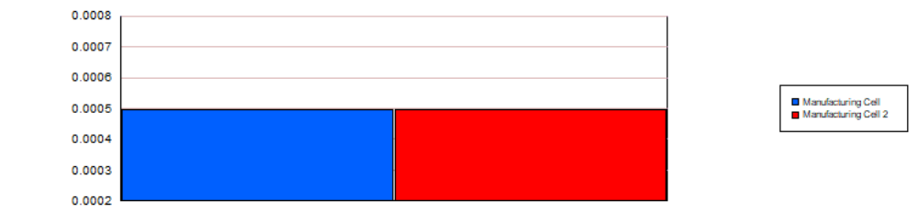
Category Overview
6.33.43AM
May 13, 2021
Unnamed Project
Time Units:
Replications:
500
Hours
Values Across All Replications
Resource
Usage
Instantaneous Utilization
Maximum
Average
Minimum
Average
Half Width
Average
Minimum
Value
Maximum
Value
0.00049451
Manufacturing Cell
< 0.00
0.00
0.0903
0.00
1.0000
0.00049451
Manufacturing Cell 2
< 0.00
0.00
0.0903
0.00
1.0000
Number Busy
Maximum
Average
Minimum
Average
Half Width
Average
Minimum
Value
Maximum
Value
0.00049451
Manufacturing Cell
< 0.00
0.00
0.0903
0.00
1.0000
0.00049451
Manufacturing Cell 2
< 0.00
0.00
0.0903
0.00
1.0000
Number Scheduled
Maximum
Average
Minimum
Average
Half Width
Average
Minimum
Value
Maximum
Value
1.0000
Manufacturing Cell
< 0.00
1.0000
1.0000
1.0000
1.0000
1.0000
Manufacturing Cell 2
< 0.00
1.0000
1.0000
1.0000
1.0000
Scheduled Utilization
Maximum
Average
Minimum
Average
Half Width
Average
Manufacturing Cell
0.00
0.00049451
0.0903
0.00
Manufacturing Cell 2
0.00
0.00049451
0.0903
0.00
Model Filename:
Page
of
4
5
D:\A_Sem_1\Simulation\Final Project\Simulation_Final_Project_Inventory_Management_Scenario2

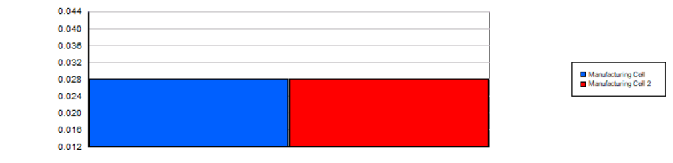
Category Overview
6.33.43AM
May 13, 2021
Unnamed Project
Time Units:
Replications:
500
Hours
Values Across All Replications
Resource
Usage
Total Number Seized
Maximum
Average
Minimum
Average
Half Width
Average
Manufacturing Cell
0.03
0.02800000
5.0000
0.00
Manufacturing Cell 2
0.03
0.02800000
5.0000
0.00
User Specified
Counter
Count
Maximum
Average
Minimum
Average
Half Width
Average
0.00
Counter 1
< 0.00
0.00
0.00
Model Filename:
Page
of
5
5
D:\A_Sem_1\Simulation\Final Project\Simulation_Final_Project_Inventory_Management_Scenario2

